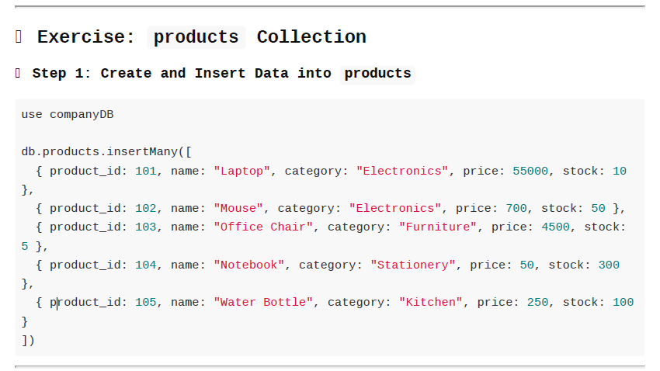

**CREATE AND USE THE DATABASE:**

use companyDB

switched to db companyDB

**INSERTING VALUES:**

db.products.insertMany([

{product_id:101,name:"Laptop",category:"Electronics",price:55000,stock:10},

{product_id:102,name:"Mouse",category:"Electronics",price:700,stock:50},

{product_id:103,name:"OfficerChair",category:"Furniture",price:4500,stock:5},

{product_id:104,name:"Notebook",category:"Stationery",price:50,stock:300},

{product_id:105,name:"Water Bottle",category:"Kitchen",price:250,stock:100}

])

**Queries to Practice:**

1. Find all products that are **not in the 'Electronics' category**.

db.products.find({price:{$gt:1000}})

2. Get all products where **price is greater than 1,000**.

db.products.find({stock:{$lt:50}})

3. Find products that have **stock less than 50**.

db.products.find({category:{$in:["Furniture","Kitchen"]}})

4. List products whose **category is either 'Furniture' or 'Kitchen'**.

db.products.find({stock:{$gte:10,$lte:100}})

5. Get products with **stock between 10 and 100**.

db.products.find({price:{$ne:700}})

6. Find all products where **price is not 700**.

db.products.find({name:{$regex:"^N"}})

7. Display all products whose **name starts with 'N'**.

db.products.find({stock:{$lte:5}})

8. Find all products whose **stock is not more than 5**.

db.products.find({category:{$ne:["Stationery","Kitchen"]}})

9. List products with **category not in ['Stationery', 'Kitchen']**.

db.products.find({category:{$nin:["Stationery","Kitchen"]}})

10. Find one product **not in the 'Furniture' category**.

db.products.find({category:{$ne:"Furniture"}})